WEEK 4 (PRACTICAL)

Task 1

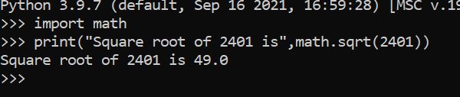

Task 2

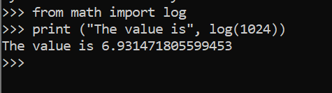

Task 3

